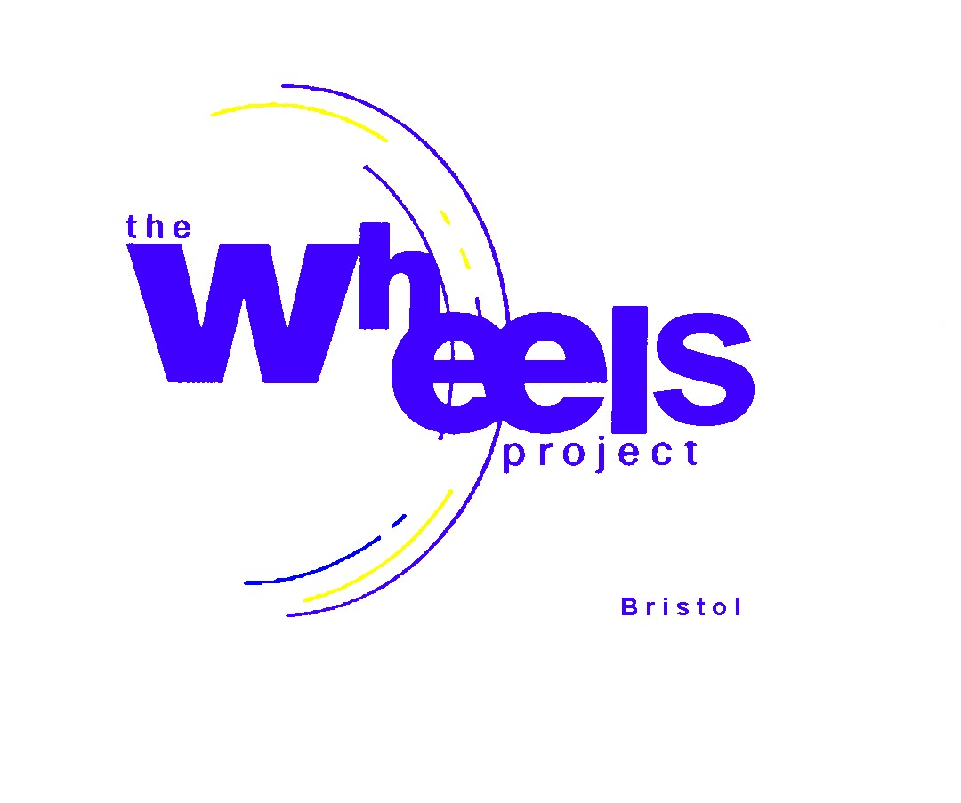
Focus Groups : EVIDENCING NEED FOR WHEELS’ PROGRAMMES
BLF Reaching Communities

Student Name (initials only) ……………… Date: ……………………..

Gender …………………………male/female Age…. ..yrs
Name of School/Organisation: ……………………………………………………………….

Have you attended Wheels before? Yes/ No

Do you have an Education Healthcare Plan? Yes/ No
(if you are not sure, please check with your Key Worker)
Do you qualify for free school meals Yes/ No/ Don’t know

Are you interested in receiving one of our courses? Yes / No

IF YES, please answer the following questions: (fill in, circle or tick your choices).

- Which of our programmes are you be interested in? (Please indicate your choices.)

- Bicycle Repair and Maintenance
- Karts
- BIKC (British Indoor Karting Championship Prep)
- Introduction to Vehicle Servicing
- Pre Driver-Training
- Mopeds CBT
- Community Vehicle

2 How would you like the programmes to be delivered? (circle your choices)

2.1 Length of each session (2.5 or 5 hours each day)

2.2 How often per week: once twice three more Doesn’t matter

2.3 Time of day:

- During the school holidays
- During the school term
- In school time
- Out of school time
- No preference

3 What size of group of students suits your learning needs? (We provide up to 2 instructors.)

1:1 1-2 1-4 (please circle your first choice of preference)

4 How do you prefer to learn when facing something new? (Tick your preference)

  - Trial and error (do it yourself and learn from your mistakes)
  - Follow a set of instructions
  - Be shown by someone who knows and then copy

5 Would you like to include other activities such as (please tick if you would)

- Electric Vehicle repair and maintenance
- Other (please state) ……………………………………………………………….

6 Do you want to include topic areas such as: (please tick up to 3 choices).

- Road Safety
- Driving and the Law
- Getting a Provisional Driving Licence
- Hazard Awareness Training (part of driving test)
- Highway Code
- Numeracy at Work
- Literacy at Work
- Managing Money
- Careers Guidance
- Employment Skills
- Job Search
- Other (please state) …………………………………………………………………

7 Are you interested in renovating a vehicle? Yes / No

If so, do you have a community group in mind which is in need of a vehicle? Yes / No

If so, which organisation would you like to suggest?

Organisation …………………………………………………………………..

8 Would you like to gain some Qualifications in motor vehicle studies? Yes / No
(We don’t currently offer any formal qualifications.)

9 What would be the main reasons why you’d like to do this course?
(Tick all of your choices but highlight the MOST important.)

- A way to have some fun
- A way to have some fun with friends
- A way to put something back into my community
- A way of testing out your interest in Motor vehicle Repair
- A way to be a safer rider/driver
- A way to maintain your own bicycle
- A way to maintain your own vehicle in the future
- A way to put a vehicle on the road (legally and safely)
- A way of developing a career generally
- A way of developing a career specifically in the motor vehicle industry

Thank you for completing these questions.

David Glossop
General Manger
April 2024

The Wheels Project Ltd, 31-32 Bonville Road, Brislington, Bristol BS4 5QH
Tel: 0117 9711711 Website: www.wheelsproject.org.uk
Registered Charity No: 1081236

