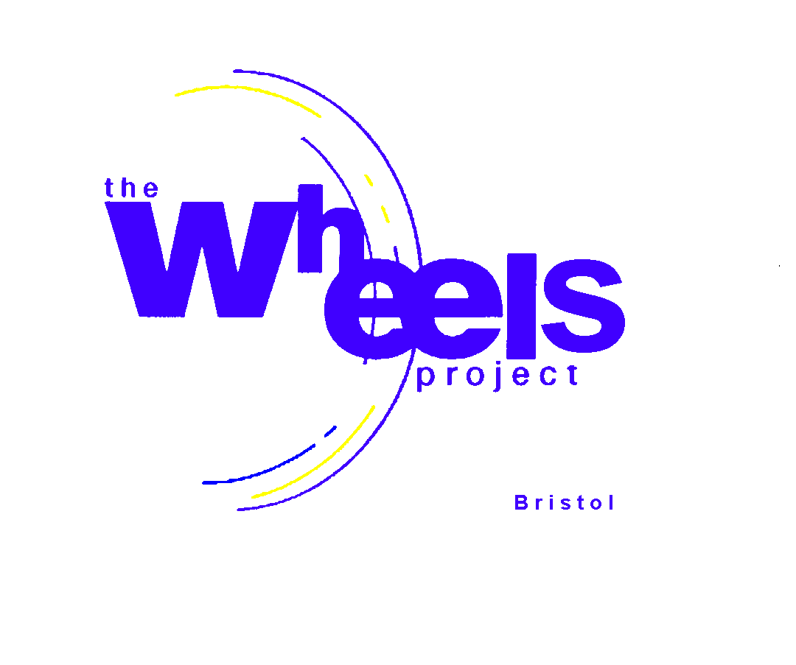
The Wheels Project Ltd

31- 32 Bonville Road
Brislington

BRISTOL BS4 5QH
Registered Charity No: 1081236

Tel : 0117 971 1711 Fax : 0117 977 2222

email : david@wheelsproject.org.uk website: www.wheelsproject.org.uk
AGENCIES’ QUESTIONNAIRE

We are conducting an analysis of need for the services currently provided by The Wheels Project for young people in your care and would appreciate you completing this questionnaire on behalf of your agency. We intend to use the information collated in applications to raise monies to fund future courses.

The purpose of this questionnaire is to evaluate our services from the perspective of the agencies and not from the young people in your care (we have a separate form for that).
___________________________________________________________________________________

KEYWORKER INITIALS ………………… ORGANISATION : …………………………………………

DATE ………………………………………….

1 Type of organisation

School/Academy Approved Alternative Learning Provider (ALP) Youth Club YOT

Other, please state …………………………………………………………………........................

2 Where are you based (postcode)?

………………………………………………………………………………………………………………

3 What is the age group of the young people you normally work with?

11-12 13-16 17-18 18-24 All

- Has your organisation referred young people to The Wheels Project in the past?

Yes/No

If yes, did our course(s) form part of an overall programme for the young person delivered by your organisation?

Yes/No

If yes, how do you use our services? (Tick more than one if necessary.)

To increase motivation
To improve behaviour
To Increase attendance with you
For Road Safety Awareness Training
For improving knowledge of driving and the law
To develop vocational skills in Motor Vehicle Studies

Other, please state ………………………………………………..
PTO

2

- How important is it for the young person to gain qualifications at Wheels?

Vital

Quite important but not the main focus

Not important

- If qualifications are important, what kind?

Units towards a specific motor vehicle qualification

Other (please suggest)……………………………….

- If qualifications are important, at what level? (please circle)

E3 L1 L2

8 How would you like to improve your links with our Project?

……………………………………………………………………………………………………………….

……………………………………………………………………………………………..........................

9 Why would you choose The Wheels Project? (Tick more than 1 if necessary.)

Meets the needs of the young people
Successfully engages young people
Easy to access
Offers qualifications
Offers qualifications towards the Foundation Learning Certificate
Has good facilities
Has good staff
Is well organized
Has good Policies in place
Offers safe, structured programmes
No other facility of its kind locally

10 When does your organisation need our programmes to be delivered?
(Tick more than 1 if necessary.)

In school time
Out of school time
During holidays

11 Does your organisation need fixed entry points onto our programmes?

We currently have fixed entry points at the start of each new term (6) and, in addition, occasionally during school holidays. Does this meet your needs?

Yes/No

If no, what would you prefer? More/Less

If more, how frequent? …………………………………………………....................

3

12 At what time of year would your preferred entry points take place?

Term 1 Term 2 Term 3 Term 4 Term 5 Term 6

School holidays No preference

13 Based on The Wheels Project providing 2 Supervisors, please state your ideal student group size?

…………………………………… students

14 Does your organisation prefer its students to be: (Tick more than 1 if necessary)

A stand alone group
Mixed with students from other organisations
No preference

15 Please indicate which of our activities you feel meets the needs of the young people from your organisation. (Tick more than 1 if necessary.)

Workshop

Bicycle repair and maintenance
Kart disassembly and assembly
Moped repair and maintenance
Car repair and maintenance
Renovation of a vehicle to gift to a community group(Local/National)
Electric vehicles repair and maintenance

Other, please state ………………………………………………………………………….

Classroom

Road safety
Driving and the law
Documentation for putting a vehicle on the road
Hazard Awareness Training (part of the driving test)
Highway Code
Numeracy at work
Literacy at work
Careers guidance
Employment skills

Job search
Impact of Motor vehicles on Environment
Other (please state) …………………………………………………………………………

Driving Activities

Karting
Taking part in a national karting championship
Driving lessons
Compulsory Basic Training (CBT) for new moped riders
Quad biking
Driving Electric vehicles
Other, please state ………………………………………………………………………….

4

16 Do you think The Wheels Project offers your organisation value for money?

Yes/No

17 Would your organisation be more likely to use our services if the cost of our courses were subsidised from elsewhere?

Yes/No

18 Does your organisation have motor vehicle training workshops on site?

Yes/No

19 What are the main things that would deter you from using our services?

Cost
Content
Location

20 Have you looked at our website (www.wheelsproject.org.uk)?

Yes/No
___________________________________________________________________________________

Thank you for completing this questionnaire, if there is anything extra you would specifically like to see us include in terms of projects and programmes that we don’t currently offer, then we would welcome your comments in the box below.

Best wishes


David Glossop
General Manager

18.10.19
Junior wheels /course forms/Organisation questionnaire of need 2019

