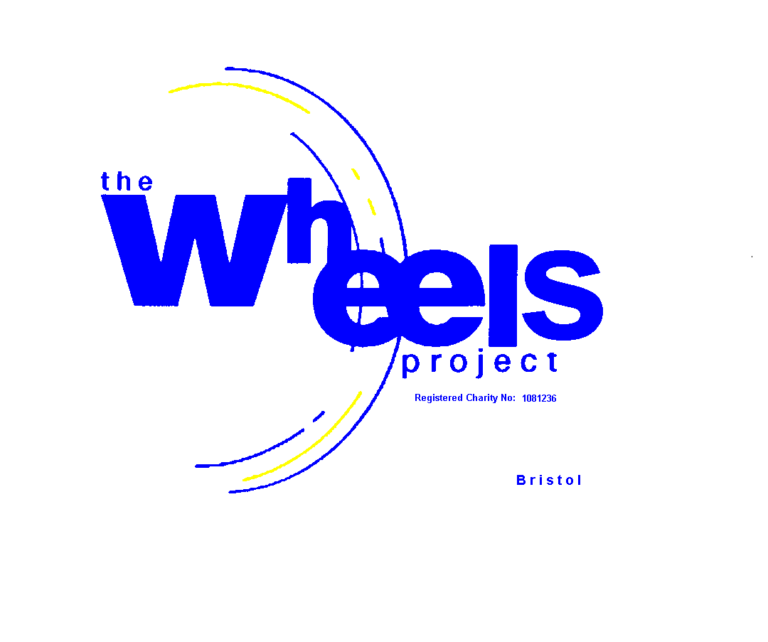

The Wheels Project Ltd
STUDENTS’ RISK ASSESSMENT

Group/(eg SCHOOL):………………………Term: …… Start Date: …………………… Organiser: …………………………………………

Please ensure that you complete this form and return it no later than one week BEFORE the start of your course
Please inform us immediately of any Safeguarding issues – this can be done verbally directly to our General Manager, David Glossop

STUDENT’S INITIALS | STUDENT’S UPN | Looked After Child? Y/N | Date of Birth | Postcode | Parent/Guardian Contact  Name and Number  (Track/Trace  Purposes)
School History  (Which secondary schools  has your student attended) | Reason for leaving | Behaviour – Key Issues  (Please detail below) |  | Medical Conditions  (Please detail below)
Due to the type of activities undertaken at the Wheels Project and given that there are particular types of tools that have to be used to carry out certain tasks, we MUST be made aware of any of the following:-
Yes No
Please tick either yes or no in the boxes to the right-hand side
Are you aware of or has your student ever been caught carrying knives and/or weapons (if you have answered yes then go to Page 2)
Are you aware of or has your student ever been caught either using or selling drugs (if you have answered yes then go to Page 2)
Are you aware of or has your student been experiencing exploitation or violence in the community (if you have answered yes then go to Page 2)
Are you aware of or has your student ever been involved in a serious incident (if you have answered yes then go to Page 2)
Should your student be taught on a 1:1 basis (if you have answered yes then go to Page 2)

If the referring organisation is referring a student that is part of a group and considered to be high risk because of current behaviour or safety issues, then the Wheels Projects insists that the student be accompanied by a key worker from the referring organisation

The Wheels Project will not accept referrals whereby the student has a history of violence or substance misuse occurring in the last two years

If you have answered ‘yes’ to any of the questions on Page 1, then please provide full details below

…………………………………………………………………………………………………………………………………………………………………………………………………………

…………………………………………………………………………………………………………………………………………………………………………………………………………

…………………………………………………………………………………………………………………………………………………………………………………………………………

…………………………………………………………………………………………………………………………………………………………………………………………………………

Please note that the Wheels Project reserves the right to refuse your referral

The Wheels Project Ltd, 31-32 Bonville Road, Brislington, Bristol BS4 5QH
Tel: 0117 971 1711 Website: www.wheelsproject.org.uk
Registered Charity No: 1081236

