The Wheels Project Ltd
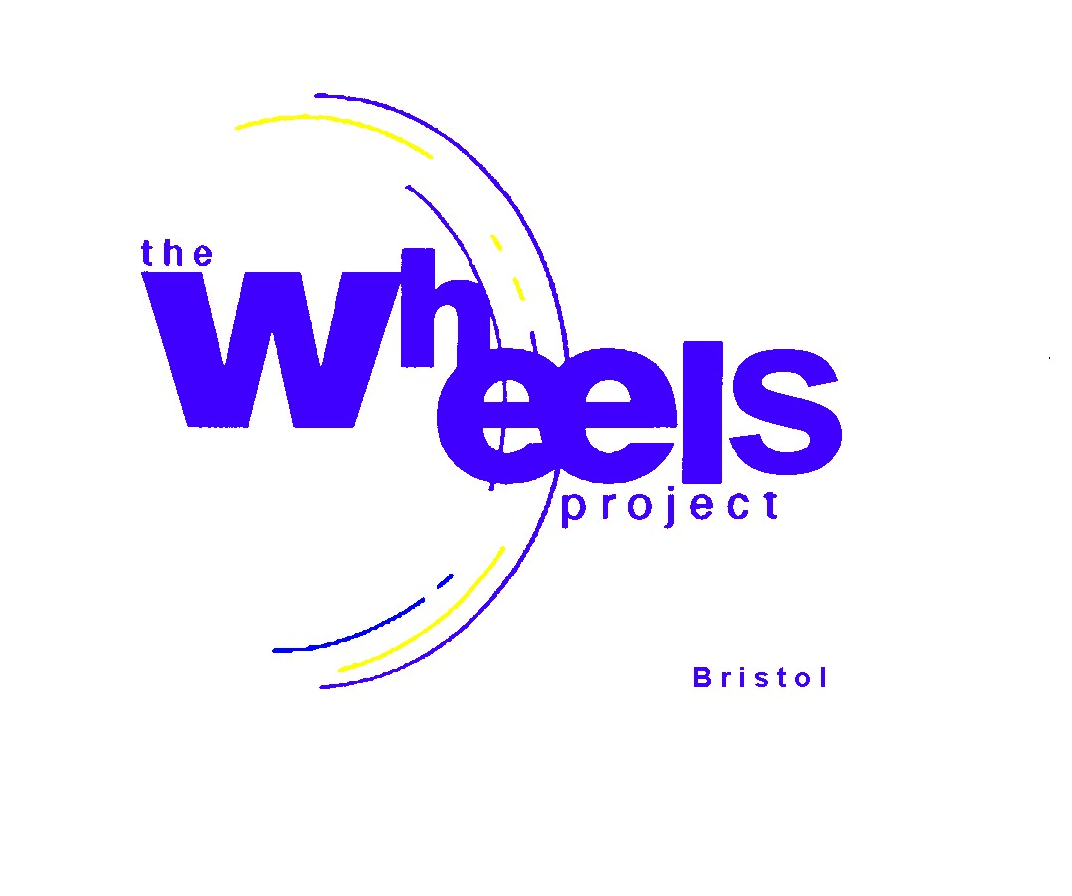
31-32 Bonville Road
Brislington
BRISTOL BS4 5QH
Registered Charity No: 1081236

JOB DESCRIPTION

POST | Trustee
PURPOSE | To develop strategies and policies which satisfy the Articles and Memorandum of the Charity.
PAY SCALE | Unpaid
HOURS PER WEEK | Not specified

MAIN DUTIES AND RESPONSIBILITIES

- Responsibility for developing effective strategic practices for working with target group as set out in the Charity’s Memorandum and Articles of Association.

- To set up and maintain an economically viable Project.

- To draw up the aims and objectives of the Project.

- Responsibility for the recruitment and management of senior staff.

- To ensure the correct implementation of all statutory employment requirements including Health and Safety, safeguarding, Equal Opportunities, Race, Disability and Age Discrimination.

- Develop, implement and review fiscal policies of the Board.

- Review Project performance at least annually

- Develop network of contacts that will support the development and maintenance of the Project.

- Develop and maintain positive links with all agencies throughout Avon involved in Education, Criminal Justice System, Local Unitary Authorities and Third Sector.

- Attend formal Board meetings on a Quarterly basis

- Identify and attract other potential new Board members

GENERAL DUTIES

- To safeguard all sensitive information encountered during the course of employment.

- To keep abreast of developments affecting the Project and duties of the post through attending training (either residential or non-residential) and attachments, as required.

- To assist in achieving the desired quality of customer service.

Person Specification

QUALIFICATIONS AND EXPERIENCE

The post holder must have proven business experience, professional competence, financial and management experience with a specialism sought in least one of the following:

- Fund raising
- Accountancy
- Marketing
- Human Resources
- Education
- Employment Law
- Health and Safety issues
- Knowledge and links to local resources
- Ex user of the Project’s services

A degree or relevant professional qualification is an advantage. Experience in a training role and knowledge of the Criminal Justice and Education Systems is an advantage. The Board aims to be as representative and diverse in its membership as to fairly reflect its local community.

EXPECTATIONS OF TRUSTEE PERFORMANCE

- Attend an induction within 1 month of appointment delivered by General manager
- Attend a minimum of 2 formal Board meetings each financial year
- Assist in fund raising events to raise monies or initiate contacts to secure tools, equipment and vehicles needed for our Community Vehicle Programme
- Provide specialist guidance and support

SUPERVISORY RESPONSIBILITY

The Board will have operational supervision of the General Manager.

BACKGROUND

The Wheels Project Ltd is a registered charity and a company limited by guarantee. Control is by partnership agreement and all partners are represented on the Board.
The Charity’s activities are aimed at the disadvantaged and in particular address the behaviour and needs of young people who have exhibited anti-social behaviour, not in Education, employment or training (NEET) and other characteristics most likely to lead into committing crime.

The annual expenditure is currently around £275,000 each year. These monies need to be identified and secured throughout the year.

Salaries for directly employed staff account for approximately £160,000. In addition, there may be seconded staff and volunteers making up the full complement. The reserves of the Charity amount to approximately £176,000, equivalent to 6 months operational and contingency costs in the event of closure.

