GROUP ORGANISER’S END OF COURSE QUESTIONNAIRE
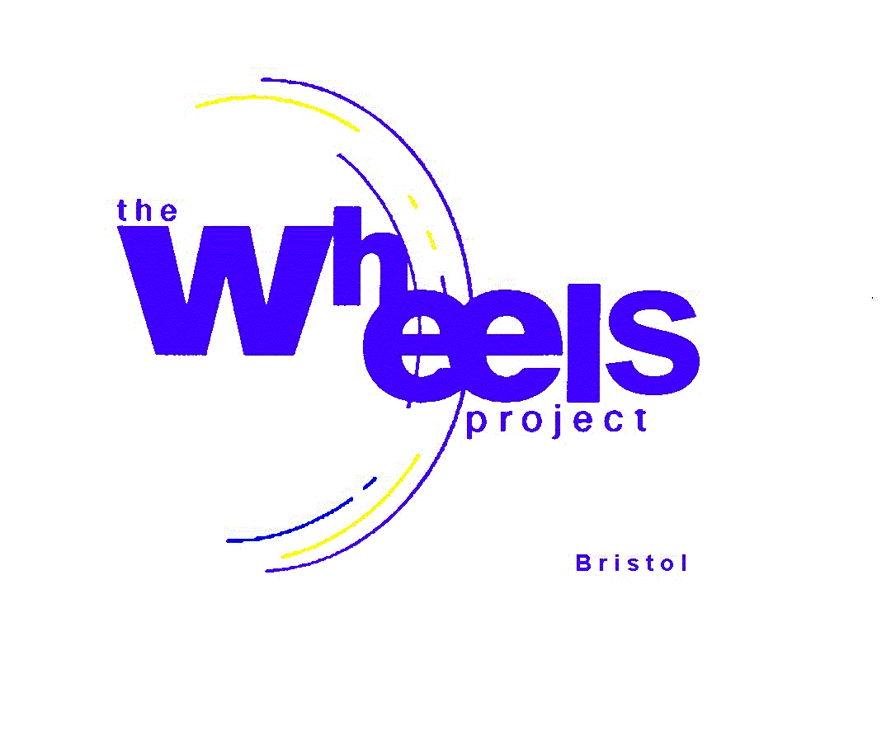

GROUP NAME: …………………………………………………………………………

STUDENT’S NAME: ………………………………………………………………………………….

The above student attended a Wheels’ course during the academic year 2017-18.

In order to evaluate the effectiveness of our courses and enable us to report back to our funders, please complete the following questions by highlighting/circling your answer.

Was there an improvement in the student’s:

- Behaviour Yes No

- Attitude Yes No

- Attendance Yes No

Did this student:

- Go on to an early college placement? Yes No

- Go on to FE? Yes No

- Leave school for a job? Yes No

- Continue at school? Yes No

- Other? Yes No

If Other, please give details: ………………………………………………………………

Please give us some written feedback on the impact our Wheels’ course has had on this student.

……………………………………………………………………………………………………………………………………………………………………………………………………………………………………………………………………………………………………………………………………………………………………………………………………………………………………………………
Thank you.
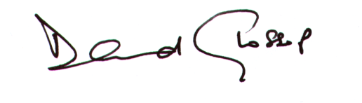
David Glossop
General Manager

The Wheels Project Ltd, 31-32 Bonville Road, Brislington, Bristol BS4 5QH
Registered Charity No: 1081236
Tel: 0117 971 1711 Email: david@wheelsproject.org.uk

Junior wheels/all forms/course forms/group organisers final questionnaire

