POLICY | The Wheels Project must protect the safety of its staff, students, key workers and all other visitors and must ensure implementation of safe and effective social distancing and hygiene measures in line with government advice to limit the potential for infection. If at any point we feel the safety of our staff, students or visitors is compromised then the task/activity must cease. Current government advice is to remain two metres away from anyone else and that certain operations are not encouraged and in some cases prohibited.  This Policy and Procedures document must be read by Wheels staff and referrers in conjunction with all other activity and site specific risk assessments in relation to the task being undertaken.
PROCEDURES
The Wheels Project is only to re-open based upon the criteria within the Code of Conduct/Learner Agreement, Roles of Staff and Student Risk Assessment documents. Specific safety information is set out in the Enhanced Hygiene and Safe Working Practice Instruction appendage. Clear direction to General Manager that if Operations cannot be managed within the requirements of the Instructions that they should not attempt to be open.

General Manager and staff will be kept informed of changes and evolving guidance via a weekly briefing.

Staff, students, key workers and all other visitors will be advised to take care to strictly observe the risk control measures present on site. They may raise any individual concerns with the General Manager.

Staff, students, key workers and all other visitors are reminded that they must self-isolate in accordance with government guidance and get a coronavirus test if they develop symptoms. The General Manager/Workshop Manager will send home any member of staff who displays symptoms if that individual fails to comply appropriately.

Staff are reminded to stay away from work should a member of their family develop symptoms, pending the outcome of a coronavirus test on that household member.

Staff, students, key workers and all other visitors are reminded that they must self-isolate for 14 days should they receive such instructions from the NHS Track and Trace service.

For those staff and who are on site, everyone will remain two metres apart, where practical.

The number of students permitted on site will be limited to four but numbers may be increased progressively, and visits from others such as contractors/referral agents will be managed via a central booking system with allocated time slots to ensure the level and flow of visitors is maintained appropriately.

Pre-visit information will be issued to visitors in the form of this document advising them of the behaviours required, the restrictions on site and a reminder of their own personal responsibility to observe site rules and information.

Visits by appointment only will be offered from Monday to Thursday 3.15pm – 4.15pm.

In order to maintain safety and avoid possible conflict on arrival for the students and their transporters, it is imperative that all students and accompanying key workers have a Coronavirus (COVID-19) test no more than two days prior to attending their session each week for the duration of their course/s. They must advise the General Manager either by phone or email of a negative test prior to attending. They must also be temperature tested on the day prior to setting off to Wheels for their morning or afternoon session.

Upon arrival at Wheels, all staff, students, key workers and all other visitors will be temperature tested outside before entering the building as an additional safety measure. Entry to Wheels will be through the main entrance at the front of the building. A register will be maintained by Wheels for each person attending Wheels.

When leaving all students, key workers and visitors will be accompanied to the exit which will be through the main emergency exit door in the main workshop.

Staff, students, key workers and all other visitors are instructed to wash hands upon arrival, throughout their session and as they leave.

Hand sanitiser will be available for staff, students, key workers and all other visitors to use where handwashing is not readily accessible.

All hand contact points and equipment will be cleaned in line with the Enhanced Hygiene Instruction.

Staff, students, key workers and all other visitors will be encouraged to raise any physical or mental health issues with the General Manager/Workshop Manager in the first instance.

General Manager/Workshop Manager and colleagues are encouraged to monitor other individuals to determine whether they are safe and well, with particular awareness around individuals and groups who may be feeling a heightened sense of risk or vulnerability due to the pandemic.

Staff are encouraged to ensure travel arrangements to and from the premises are safe and sustainable whilst they are at work. Shared vehicles such as the Wheels minibus/other Wheels vehicles and staff vehicles will be sanitized immediately before and after use. Where the Wheels minibus is to be used then the controls, cab and doors are to be thoroughly wiped down between uses.

Where Tools and equipment are shared or required by multiple users they must be thoroughly wiped clean after each use using sanitising wipes.

Information and signage to help visitors observe social distancing will be provided. Areas where queues may form will be marked with distance markers..

Staff are authorised to remind students of the requirements where these are seen to be ignored. This would generally be gentle reminders, although repeated and wilful transgressions by the same individuals will ultimately require a request for them to leave the premises.

First aid for staff, students, key workers and all other visitors will be carried out by Wheels nominated first aider(s) wearing enhanced PPE in accordance with the provisions in the Enhanced Hygiene Instruction.

Hand contact points will be cleaned regularly in accordance with the Enhanced Hygiene Instruction.

Toilet cleaning will be undertaken within the provision of the Enhanced Hygiene Instruction. Queue management at toilets will be managed primarily via signage.

Individual paper towels and hand wash will be provided in each WC.

PPE equipment will be worn in accordance with the Enhanced Hygiene and Safe Working Practice Instruction appendage. In addition. All Staff, students and Keyworkers issued with a set of personal overalls and boots which they alone will use for the duration of their time at Wheels. The overalls will be cleaned appropriately but not less than once a term.

RISK ASSESSMENT
Risk | Score  Red = High  Yellow = Medium  Green = Low |  | Date | Notes
Covid-19 infected staff on arrival |  |  | 14.7.20 | Three of our four staff are aged over 60yrs and amongst vulnerable group
Replace isolated or sick staff |  |  | 14.7.20 | Our two most vulnerable staff are our supervisors. We have a reserve and GM in regular contact with appropriate recruitment agency GM cover by OM
Covid-19 infected students on arrival |  |  | 14.7.20 | Students, staff and visitors are screened before entering Wheels Covid-19
Covid-19 transferred in programme time |  |  | 14.7.20 | Procedures in place to minimise passing on infection
Covid-19 R value exceeds score of 1 |  |  | 14.7.20 | Recent press reports Government thinks strong possibility of R =1.7 in September 2020 and will rise in winter
Bookings reduce & generate less than £10k/term |  |  | 14.7.20 | 7 out of 9 programme slots booked for term 1 in Sept 2020 with £8,400 secured
Furlough scheme finishes 31.10.20 |  |  | 14.7.20 | Although we are not planning to claim JRG after 31.8.20 this key safety net makes us very vulnerable if bookings do not continue over the winter due to a second wave of Covid-19
Trusts/Foundations remove financial support |  |  | 14.7.20 | Indications are that forecast support from current funders is continuing and even increasing slightly (Gosling £8K)

The Wheels Project Ltd
The Wheels Project Ltd, 31-32 Bonville Road
Brislington. Bristol BS4 5QH
Registered Charity No: 1081236
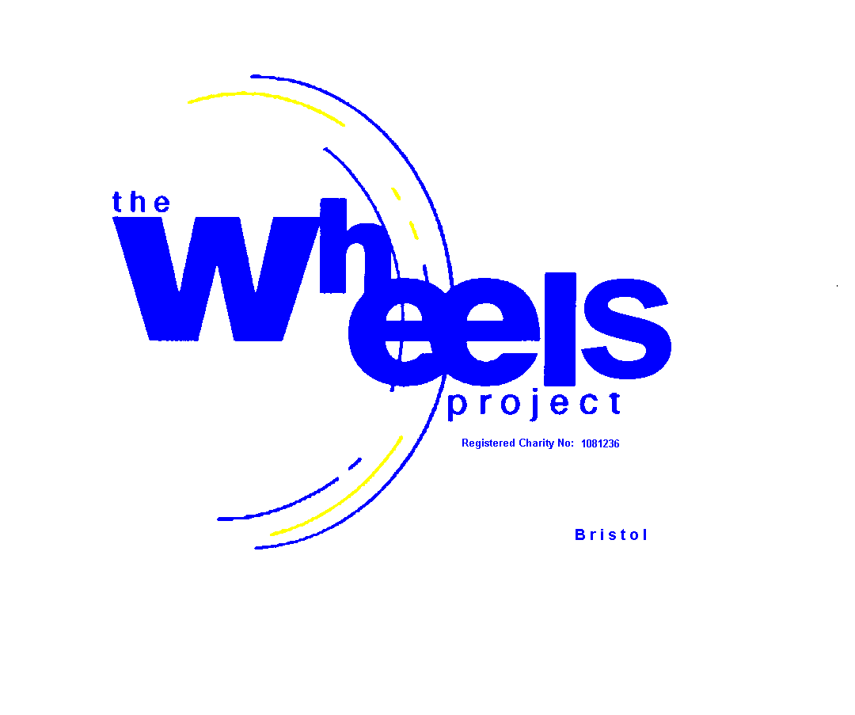

ENHANCED HYGIENE
AND
SAFE WORKING PRACTICE INSTRUCTION
APPENDAGE

Table of Contents
- Responsibilities 6
- Context 7
- Personal Protective Equipment (PPE) 8
3.1 Preventative Controls and Best Practice 8
3.2 COVID-19 Testing 10
3.3 Cleaning/Decontamination 11
3.4 Disposal of Contaminated PPE 12
3.5 Management of Potentially Soiled Laundry 13
3.6 Food and Drink
- Social Distancing 15
- Testing Process 16
5.1 Temperature Testing 16
- Management Reporting Process 17
- Return to Work 18
- Sick Leave Payment 19
- Adherence to This Guideline 20
- Medical Examinations 21

1. Responsibilities
This policy shall apply to all employees, contractors, sub-contractors and anyone visiting the Wheels Project. No-one shall be exempt from the testing procedures.
Staff, visitors and students must report any case of suspected COVID-19 should they have had close contact with a suspected or confirmed COVID-19 case.
Close contact is defined as:
- Being within approximately 1 metre of a person confirmed as having a positive case of COVID-19
- A person can be contagious 48 hours before the symptoms show up as well as after symptoms are present
Close contact can occur while:
- Caring for, living with, visiting, or sharing a room/health care waiting area
- Having direct contact with infectious secretions of a COVID-19 positive case e.g., being coughed on, etc.
Staff, students and visitors that have any symptoms related to the virus, a temperature of 37.6°C or over, fever, dry cough, sore throat or respiratory issues shall self-isolate and not come to the workplace. They shall inform the General Manager/Workshop Supervisor and take advice from the local health care authorities (NHS).
All staff, students and visitors shall follow the fundamental controls e.g. regular handwashing, no physical contact and follow the 1 metre physical distance (social distancing) rule to minimize close contact. If any symptoms develop, the individual(s) must self-isolate

2. Context
The coronavirus (COVID-19) is a rapid evolving respiratory virus. Symptoms range from a mild cough to pneumonia. Some people recover easily, others may get very sick, very quickly. It is highly contagious and there is evidence that it spreads from person to person.
People with coronavirus may experience:
• fever
• flu-like symptoms such as coughing, sore throat and fatigue
• shortness of breath.
As a preventative measure The Wheels Project shall have in place a formal, proactive testing procedure. Temperature screening shall ensure any individual(s) with a fever of (37.6°C or more) are restricted from entered the premises. Temperature screening is proposed as a pre-requisite in order to be able to enter the premises..
A copy of this policy will be displayed at each screening point.

3. Personal Protective Equipment(PPE)
3.1 Preventative Controls and Best Practices:
Personal Hygiene
Be socially responsible and practice good personal hygiene habits. Following the recommendations below can drastically reduce risk exposure.
Wash hands often for 40-60 seconds every time, scrub hands with soap for at least 20 seconds:
- Before and after preparing food
- After going to the toilet
- Before and after eating
- After coughing and sneezing
- After removing personal protective equipment (PPE) such as masks and disposable gloves.
Use hand sanitizers if soap and water is NOT available.
Maintain good indoor ventilation.
Avoid contact with live animals including poultry and birds, and consumption of raw and undercooked meats.
Avoid crowded places and close contact with people who are unwell or showing symptoms of illness.
Avoid sharing food, cutlery, crockery, utensils and other personal hygiene items.
Avoid physical contact such as shaking hands and avoid touching your face or rubbing your eyes.
Cover your mouth with a tissue when coughing or sneezing and dispose of the soiled tissue in the rubbish bin immediately and wash hands.
Seek a nominated Wheels First Aider promptly if you are feeling unwell.

General Health & Hygiene
Clean using alcohol-based wet wipes, screens, keyboard, mouse, phone, chairs and arm rests before usage.
Clean and disinfect frequently touched objects and surfaces using detergents or disinfectants cleaning spray or wipe (i.e. screens, keyboards, mouse, chair arms, common areas).
Provision and regular use of alcohol-based hand sanitizer dispensers.
Maintain at least 2 metres distance between yourself and anyone who is coughing or sneezing.
Open windows if possible.
Do not come to work if you are unwell.
Avoid organising gatherings in the office unless it is business critical.

3.2 COVID-19 Testing:
Appropriate PPE for testing staff, students and visitors shall be made available. No testing shall take place where PPE is not available. It is the responsibility of the Wheels Project to have adequate and suitable PPE available at points of use.
All thermo-testers shall have at a minimum the following PPE available at the point of use. Where stock is depleted during testing the task will stop and replenishments sought.
Testing PPE shall include;
Surgical N95 Respirators or P2 Respiratory masks
Surgical or other approved gloves (note: non-medical gloves are not permitted or suitable in the prevention of COVID-19. It is suspected at this stage that COVID-19 may remain embedded in cloth surfaces
Long sleeve medical gown or approved medical apron shall be worn

3.3 Cleaning / Decontamination:
Appropriate PPE shall be made available for staff to carry out any cleaning duties that are required. No cleaning shall take place where PPE is not available. It is the responsibility of the Wheels Project to have adequate and suitable PPE available at points of use.
For all suspected or preventative environmental cleaning, a procedure shall be developed and used appropriately to reduce risk to both staff and workers. PPE is required to prevent:
- Exposure to microorganisms
- Exposure to cleaning chemicals (e.g., disinfectants)
- Reduce the spread of microorganisms from one staff to the other within the area (when used correctly)
Cleaning should be performed by well trained staff, using the proper PPE. The correct donning and doffing of PPE should be followed. The following PPE items are suggested for use when cleaning facilities likely to be contaminated by COVID-19:
- P2 dust disposable mask
- Other masks (according to SDS) will be used only if disinfecting is to be performed
- Goggles or face shield
- Disposable long-sleeved coveralls
- Disposable chemical gloves.

Best practice for PPE for cleaning staff is as follows:
- Perform hand hygiene immediately before putting gloves on and directly after removal
- Train cleaning staff on appropriate use, application, and removal of required PPE for all environmental cleaning procedures and tasks for which they are responsible
- Keep sleeves at or above the elbow to not interfere with glove use or hand hygiene
- Wear rubber-soled closed toe shoes or boots (i.e. not sandals), to prevent accidental injury (e.g. slips and falls) and exposure to cleaning chemicals, dirt, or bacteria
- Remove wristwatches and hand jewellery before starting cleaning tasks – these items can tear gloves and can also harbour microorganisms
- All PPE (reusable and disposable) should be in good supply, well-maintained (good quality, appropriately stored stocks), cleaned before use and in good repair
- Use chemical-resistant gloves (e.g. nitrile, latex) for preparation of cleaning chemicals.

Note. Poor fit of PPE components is an often-underestimated risk factor for PPE users. Coveralls, respirators, goggles, gloves and boots need to be provided in a variety of sizes.

3.4 Disposal of Contaminated PPE
Disposable PPE should be treated as potentially infectious material and disposed in accordance with national rules. The use of disposable or dedicated cleaning equipment is recommended; non-single use PPE should be decontaminated using the available products.
When other chemical products are used, the manufacturer’s recommendation should be followed, and the products prepared and applied according to them. When using chemical products for cleaning, it is important to keep the facility ventilated (e.g. by opening windows) in order to protect the health of cleaning personnel.

3.5 Management of Potentially Soiled Laundry
Wear disposable gloves when handling dirty laundry from an infected person and discard after each use. If using reusable gloves, they should be dedicated for cleaning and disinfection of surfaces for COVID-19, should not be used for other household purposes and should be washed with soap and water before being removed. Wash hands immediately after gloves are removed.
- Avoid shaking dirty laundry to minimize the possibility of dispersing the virus in the air.
- Launder items as appropriate in accordance with the manufacturer’s instructions. If possible, launder items using the warmest appropriate water setting for the items and dry items completely.
- Dirty laundry from an infected person should not be washed with other laundry, and segregation of laundry is recommended.
- Clean and disinfect laundry container as per surface cleaning procedures. If possible, consider placing laundry in a liner bag that is either disposable or can be laundered with the clothing in it, as this minimizes contamination potential.
All contaminated clothing must be treated as potentially infectious material. All clothing must be removed from the premises.

3.6 Food and Drink
3.6.1 Drink
Wheels supplies hot and cold refreshments free of charge along with cups, mugs and glasses required. These vessels should be put directly into the dishwasher after use.
3.6.2 Food
The Wheels Project does not provide food but will allow students and key workers to bring food into the work place on the provision that they dispose of it in the bin provided in the kitchen area at the end of each session. Failure to do so may lead to the withdrawal of this privilidge.

4. Social Distancing
Social Distancing
All staff, students and visitors should practice a 2 metre rule to avoid close contact where possible.
Maintain at least 2 metres distance between yourself and anyone who is coughing or sneezing (although the minimum recommendation is 1 metre in line with current government guide lines for England 9th July 2020).
Why? When someone coughs or sneezes, they spray small liquid droplets from their nose or mouth which may contain the virus. If you are too close, you can breathe in the droplets, including the COVID-19 virus if the person coughing is infected.
Avoid touching eyes, nose and mouth
Why? Hands touch many surfaces and can pick up viruses. Once contaminated, hands can transfer the virus to your eyes, nose or mouth. From there, the virus can enter your body and can make you sick.
Practice respiratory hygiene
Make sure you and the people around you follow good respiratory hygiene. This means covering your mouth and nose with your bent elbow or tissue when you cough or sneeze. Then dispose of the used tissue immediately and wash your hands.
Why? Droplets spread virus. By following good respiratory hygiene, you protect the people around you from viruses such as cold, flu and COVID-19.

5. Testing Process
5.1 Temperature Testing
Before setting off to Wheels for a session - all students and key workers must be tested by their referral organisation no more than one day prior to attending their session at the Wheels Project In this event, if anyone tested is found to have a temperature in excess of 37.6°C they must be excluded from attending the Wheels Project and go into isolation for a two week period. The key worker should report this outcome to the Wheels Project immediately.
On arrival at Wheels - all staff, students and visitors will be subject to mandatory temperature checks on a daily basis. Testing must be done using FLIR infrared cameras. Social distancing requirements must be strictly observed by the Wheels nominated First Aider(s) using the FLIR infrared cameras. A minimum distance of 2 metres must be maintained whilst testing is being conducted.
Temperature screening of staff, students and visitors is conducted daily to help monitor symptoms of COVID19. A record will be maintained to show who has been tested and details of temperature recorded of anyone who exceeds 37.6°C.Temperature screening will be conducted outside the entrance of the premises.
If the scanner’s reading result is within the normal range of body temperature (equal to or less than 37.6°C) then it is considered safe to allow access to the premises. If a person’s temperature is in excess of 37.6°C, the designated screener will not allow the person to enter the premises. In the instance of a group of students arriving together then the whole group will be refused entry to the premises, even if just one member of the group records a high temperature in excess of 37.6°C.
In the event of an individual or group of individuals being refused entry into Wheels as a result of either temperature testing or symptoms developing such as persistent coughing and runny nose, then there are a number of options that maybe available:-
- Any accompanying key worker will be asked to provide return transport to a place of isolation
- The referring organisation will be contacted immediately by the Wheels Project and asked for guidance. In the absence of a key worker the student/s will be asked to make their own way home

6. .Management Reporting Process
The General Manager shall act immediately if a high temperature reading is reported to them by a Wheels nominated First Aider.
In the instance of it being a member of staff then The General Manager will advise the person tested that they will need to leave the premises and not return to work. All persons that may have been in contact with this person should be identified and temperature checked.
Where an individual(s) is/are suspected to be COVID-19 positive and require medical intervention, evacuation procedures shall be initiated.. All steps shall be taken to reduce exposure to anyone on the premises and the general public. There must be no interactions with anyone during the isolation and evacuation process.
Individual(s) suspected of being COVID-19 positive shall not be allowed to return to the general population to stem the spread of the virus.
A copy of this policy must be emailed to the person who has a high temperature so they can review the policy and procedure.
To manage the COVID-19 crisis, sensitive health information and other personal data will need to be collected to take protective measures (e.g. symptoms, positive for COVID-19, personal travel).
However, this sensitive information is subject to data privacy and protection laws around the world. It is the Wheels Project’s responsibility to protect the privacy of this information. This collected data must:
- Only be collected if necessary, to manage the COVID-19 crisis
- Be strictly access-controlled and provided only to people with a need to know the information
- Be secure, in line with the standard regulations
- Be maintained in the strictest confidence
- While a positive employee’s identification may necessarily need to be disclosed to some people when performing contract tracing, such people should be reminded of the importance of confidentiality.

7. Return to Work/The Wheels Project
An individual may only return to work/The Wheels Project once their temperature readings are below 37.6°C for a period of two consecutive days and no other symptoms of COVID-19 are present.
If an individual has tested positive for COVID-19 by a medical professional, they must not return to the premises until they produce a negative test result. A person confirmed with COVID-19 will be monitored by state health authorities during their isolation period and should follow the guidelines provided.

8. Sick Leave Payment
Provided the company’s temperature checking procedures and general terms relating to sickness absence are complied with, the person is entitled to be paid out of accrued sick leave hours, subject to the usual deductions for use of sick leave.

9. Adherence to this policy
Failure to follow this policy will result in disciplinary action up to and including dismissal.

10. Medical Examinations
The company reserves the right to seek medical advice and individual(s) must submit to a medical examination by a company-nominated doctor or specialist, the results of which individual(s) will be required to provide to the company.
Examinations shall be conducted, and all medical correspondence shall be in line with local regulations including medical confidentiality.

